Article

A Predictive GIS And Remote Sensing Model for Mapping Potential Gold and Base Metal Mineralization Within the Bibiani-Anhwiaso-Bekwai District of Ghana.

Bright Andoh 1,2, *, Prince Sule 2, Elisha Anankansa 1, John Ayer 2, and Mathew Osei 3,

|  |
| --- |
| **Citation:** To be added by editorial staff during production.  Academic Editor: Firstname Lastname  Received: date  Revised: date  Accepted: date  Published: date    **Copyright:** © 2023 by the authors. Submitted for possible open access publication under the terms and conditions of the Creative Commons Attribution (CC BY) license (https://creativecommons.org/licenses/by/4.0/). |

1 Department of Geomatic Engineering, Kwame Nkrumah University of Science and Technology, Kumasi, Ghana

2 Affiliation 2; e-mail@e-mail.com

**\*** Correspondence: e-mail@e-mail.com; Tel.: (optional; include country code; if there are multiple corresponding authors, add author initials)

**Abstract:** Mining in Ghana historically concentrated in specific towns like Obuasi, Tarkwa, and others. Given this concentration, there's an emerging need to harness contemporary technologies like remote sensing for expansive mineral exploration. A geological remote sensing investigation was executed in the Bibiani-Anhwiaso-Bekwai district, leveraging ASTER imagery to map hydrothermal alterations linked to gold mineralization. This region was selected due to its abundant gold occurrences, facilitating ample training data for the study. The district's geology, dominated by the Precambrian Metamorphic rocks, showcases rich Oxysols soils, leading to prevalent gold and bauxite mining activities. Employing diverse remote sensing techniques on the ASTER dataset, geological features were pinpointed, aiding in identifying pathfinders linked to gold. A target exploration map was formulated via ASTER data hill shade processing combined with hydrothermal and structural mapping, analysis, and historical data. The newly generated data offers valuable perspectives, enhancing future exploration endeavors.

**Keywords:** Mining in Ghana; GIS; Remote Sensing; ASTER imagery; Hydrothermal Alteration; Gold Mineralization; Geological Mapping; Oxysols soils; Exploration Map; Precambrian Metamorphic rocks; Bibiani-Anhwiaso-Bekwai district, Ghana

1. Introduction

Mineral exploration activities require robust predictive models that would result in accurate mapping of the probability that mineral deposits can be found at a certain location. The demand of mineral resources and also the need to find new deposits and map them have increased significantly in proportion to an increasing population with large working but largely unemployed youth. This has led to large artisanal mining with no skills leading to ecological destruction of large arable lands. The exploration and mapping of potential mineral deposits require the application of diverse methods and techniques, based on the geological and mining knowledge of the region under investigation and on the application of predictive models of mineral potential (Varet, 2012). Mineral resource mapping is an important type of geologic mapping activity and usually covers a great part of studies focused on spectral analysis (Longhin et al., 2001), geological mapping (Harris, *et a*l., 2003), and mineral alteration mapping (Tangestani, and Moore, 2002). Satellite remote sensing images have been widely and successfully used for mineral exploration since the launch of Landsat in 1972. This application relies mostly on the capability of the sensor to register spectral signatures and other geological features related to mineral deposits.

Gold is one of the most important mineral commodities that have been searched with the use of satellite remote sensing images over the last 30 years (Torres, 2007). Mineral potential exploration becomes very essential in managing land destruction so that only places likely to have any deposits at all may be mined. The term, mineral potential, refers to the probability that mineral deposits of the type sought can be found at a certain location (Carranza, 2008). It is obvious that a large part of the earth’s surface and surface minerals in accessible regions have already been found and mined. Therefore, new searches must be more complex in principle and would require the application of sophisticated spatial data analysis techniques (Moon, and Evans, 2006).

Mineral exploration companies use diverse types of data sets to search for new mineral deposits. Data sources vary from geologic maps, hyperspectral airborne and multispectral satellite images, and geophysical images to databases in many formats. GIS is an ideal platform to bring these differing datasets together and deliver meaningful outcomes (Torres, 2007). Within the context of mining exploration, GIS is an essential tool for analyzing large volumes of previously collected data and Remote sensing images are also very crucial in obtaining current data to support decision-making in mineral exploration (Bonham-Carter, 1994). Since the exploitation of the minerals would have a negative impact on the lives of the community people and the environment, appropriate models must also incorporate ground remediation methods and procedures in order to reduce the resulting environmental effects.

Some of the mineral resources mined in Ghana include gold, diamond, oil, manganese, salt, and bauxite, with gold being the major mineral mined in commercial quantities. The continuous existence of the minerals in the soils of Ghana is a strong indication that Ghana can build a strong and robust economy when these minerals are mined using the appropriate techniques. It becomes a great challenge in mineral exploration and exploitation to research and present methods by which these minerals could be easily identified and mapped without causing much damage to the people and the environment. Several numerical methods have been devised for the district-scale mapping of mineral potential. These can be categorized into knowledge-driven and data-driven types, depending on the nature of the inference procedure used. Knowledge-driven models use subjective evidence based on expert knowledge of processes that might have led to the formation of mineral deposits in a given geological setting, where no or very few mineral deposits are known to occur (Carranza, 2008). Data-driven models use objective evidence based on the associations between evidential features and known deposit locations (Abedi et al., 2013; Carranza, and Hale, 2001).

Mining activities in Ghana for a very long time were concentrated in a few towns and communities such as Obuasi, Tarkwa, Awaso, Bogoso, Kade, Preastea, and Nsuta among other towns (Darko, 2012). For this reason, there is a need to embrace the application of recent and reliable technologies such as remote sensing in exploring other deposits. The location and quantity of such minerals are often only known through traditional methods of exploration involving drilling and laboratory testing of soil and rock samples

One major important step in mineral exploration is the selection of suitable areas. The best and most promising areas make it possible to identify mineral deposits easily, quickly, and cheaply. The use of remote sensing promises to be an excellent technique for identifying and investigating suitable areas of mineral deposits. With GIS The expensive nature of field prospecting, the large workforce, the time, and the numerous operations that prospectors have to go through before a mineral is discovered may be attributed to the lack of mineral potential maps for larger areas. Also, Remote Sensing data can serve as a topographic map for exploration maps where there is no such map (Kwang et al., 2014).

It should be appreciated that there is one important limitation of remote sensing data the depth aspect. Remote sensing data has a depth penetration of approximately a few micrometers in the very near-infrared region, to a few centimeters in the thermal infrared, and some meters (in hyperarid regions) in the microwave region. Therefore, in most cases, a remote sensing data interpreter has to rely on indirect clues, such as general geologic setting, alteration zones, associated rocks, structure, lineaments, oxidation products, morphology, and vegetation anomaly, since only rarely is it possible to directly pinpoint the occurrence and mineralogy of a deposit based solely on remote sensing data. (Rajesh, 2004). In this study, the multispectral ASTER data, which can define mineralogy is expected to play a greater role in gold exploration, by helping to delineate ore minerals or their pathfinders such as alunite, kaolinite, chlorite, muscovite, and goethite, and help to predict potential areas of gold deposits within the Bibiani-Anhwiaso-Bekwai district through an approach of establishing a relationship between the known deposits in the Bibiani and Chirano deposits and similar occurrences in the district.

In as much as mineral exploration in Ghana can be traced as far as the tenth century, the application of modern technologies especially remote sensing in prospecting mineral deposits which is widely used in developed countries, has not attracted much attention in Ghana. The mineral deposits at Chirano and Bibiani were discovered using geological mapping which was followed by drilling and laboratory testing of soil and rock samples. This method involves much money and time even though results are not always guaranteed. The current mine operation has continued for a long and is almost mined out, therefore, it is important to identify and locate new areas to extend the mine life.

Mineral exploration in some areas across the country failed to produce favorable results after much cost and time investments causing financial loss to the companies that went into such experiments. High potential deposits remain undiscovered and unexploited because of high investment costs in exploration and its attendant risk or uncertainty of yield. The underestimation of gold deposits in the district has contributed largely to the illegal mining operation throughout the district as the estimated quantity of gold at the sites overtaken by illegal miners is not known, and companies willing to practice legal large-scale mining activities are not motivated to venture. As a result, the country is not able to fully develop and expand the mining industry to increase employment and generate more foreign exchange for economic growth to prevail.

2. Materials and Methods

*2.1. Study Area*

The Bibiani-Anhwiaso-Bekwai District was chosen for this study because it contains a sufficiently large number of gold occurrences to provide enough training data for the investigation. The district was established in 1988 by the Local Government (Establishment) Legislative Instrument (L.I) 1387 under the then Local Government Law, 1988 PNDCL 207 now replaced by the Local Government Act, 1993, Act 462. Figure 3.1 is an illustration of the study area. Bibiani is the district capital. The district is bounded in the North by the Atwima Mponua District in the Ashanti Region, South by the Wassa Amenfi District in the Western Region, and to the West by the Sefwi Wiawso District in the Western Region and East by the Denkyira North and Amansie East districts of the Central Region and Ashanti Region respectively. The total land area of the district is 873 km square.

code.

*2.1.1. Geological Settings*

The study area is within the Paleoproterozoic terrain of Southwest Ghana. Paleoproterozoic supracrustal rocks in southwest Ghana are subdivided into two main groups; the volcanic-sedimentary Birimian Supergroup and the overlying clastic sedimentary rocks of the Tarkwaian Group. Figure 3.2 is an illustration of the Southwestern Ghana geology of which the study area falls. These Paleoproterozoic rocks have been subjected to two main orogenic cycles between ~2250 and 2088 Ma, the progressive Eburnean orogeny, also referred to as the Eburnean 1 and 2 orogenies (Allibone et al., 2002). The Birimian successions comprise sedimentary/volcaniclastic lithologies which consist of primarily mafic rocks erupted and emplaced during the Eburnean orogenic cycle, such as tholeiitic basalts and lesser calc-alkaline and rhyolitic volcanic (Lower Birimian). It is thought that these rocks make up the basement of the younger Birimian turbiditic fluvial and sedimentary rocks and metamorphic equivalents such as phyllites and argillites, forming the sedimentary basins in the region (Allibone et al., 2004). These constitute five northeast-trending volcanic belts (Upper Birimian). Collectively the volcanics and sediments described above are known as the Birimian Supergroup. Available field evidence suggests that the volcanic and sedimentary rocks are lateral equivalents (Leube et al., 1990). The Tarkwaian system is dominated by coarse clastic sedimentary rocks of fluvio-deltaic origin, sandstones, conglomerates, quartzites, and other metamorphic equivalents such as phyllites and argillites. Allibone et al., (2004) note that deposition of this group of sedimentary rocks occurred coincidentally with the initial deformation of the Birimian Supergroup early in the Eburnean 2 orogeny but prior to granitoid emplacement. Generally, the Tarkwaian Group sediments are confined to the mafic igneous belts associated with the Birimian Supergroup, usually occurring either in unconformable stratigraphic contact or as imbricated fault-bounded slices.

*2.1.2. Local Geology*

The geology of the district is dominated by the Precambrian Metamorphic rocks of the Birimian and Tarkwaian formations. The Oxysols soils are rich in mineral deposits making mining the most important and lucrative economic activity in the district. The most noted minerals are gold and bauxite. The companies dealing in mining include; Chirano Goldfield Limited at Chirano and Bossai Minerals Limited at Awaso, and recently, Resolute Mines acquired the Bibiani concession hoping the start operations soon. The geology of the Chirano concession is presented here because the datasets that form the integration model such as the lithology, geochemistry, and occurrence points were obtained from the Chirano gold mines. The Chirano gold deposits are hosted near the boundary of Birimian mafic igneous rocks with Tarkwaian sedimentary rocks. Where faulted, this boundary has been intruded by tonalite. Volcano-sedimentary rocks and the tonalites are metamorphosed to greenschist facies assemblages and in the least strained regions are generally unfoliated (Allibone et al., 2004). Previously, it was considered that tonalite intrusions were the main host to gold Mineralization (Allibone et al., 2004). However, recent exposures in open pits have shown that the volume of tonalite has been over-estimated at several deposits, which are mostly hosted within strongly hydrothermally altered mafic igneous rocks. Basaltic and doleritic rocks, with subordinate gabbro, tonalite, and diorite intrusions of the Sefwi-Bibiani volcanic belt dominate the western domain. The central domain is composed mainly of Tarkwaian Group rocks of siltstone, sandstone, grit, and conglomerates with minor basaltic and doleritic rocks. Birimian sedimentary rocks made up of turbiditic graywackes, siltstones, and minor fine-grained sandstones on the western margin of the Kumasi basin comprise the eastern domain (Allibone et al., 2004). Between the western and central domains is the Chirano Shear Zone (CSZ) which varies in width along strike, with the larger graphitic and chloritic Bibiani shear zone separating the central and eastern domains. Mafic rocks of the Sefwi Volcanic belt such as basalts, dolerites, and gabbros exist in the western part of the Chirano Mining Lease and that of the Chirano North Gold project and were intruded by Chirano granites including tonalites, quartz-feldspar porphyry, and granodiorites.

In addition, there are diorites and gabbros. To the east are Tarkwaian sediments comprising mudstones, siltstones, arkosic sandstones, and polymitic. Conglomerates. A fault, known as the Chirano Shear Zone (CSZ) marks the contact between the Tarkwaian sedimentary rocks and the Sefwi volcanic rocks. To the east of the Tarkwaian sediments are the Kumasi Basin metasediments mainly phyllites, greywackes, and schists. The Bibiani Shear Zone (BSZ) is the fault contact between the Tarkwaian sediments and the Kumasi Basin sediments (Allibone et al., 2004). BSZ, CSZ, and their splay structures are the main structural controls on the localization of gold within the Chirano and Bibiani districts (Allibone et al., 2004). Recent exposures in pits and road cuts in the Chirano Mine area have shown that gold is hosted in sheared, brecciated, veined, and hydrothermally altered basalts, dolerites, quartz veins, and granites (Stuart, 2007). A strong correlation was established between the presence of fine-grained disseminated pyrite + silica + albite + ankerite + sericite and the concentration of gold in the altered rocks (Stuart, 2007). The relatively minor felsic intrusions present are usually distinguished by high radiometric potassium content. There are no isotopic age-dates reported for intrusives within the area. Similar intrusives further south yielded a U/Pb date (on zircon and monazite) of about 2180 Ma which suggests the intrusives are probably coeval with volcanic activity in the belt (Kurtsen et al., 1992). CSZ marks the FW contact of the ore body and there is no clear HW fault. The Chirano Shear Zone (CSZ) dips 70º to 80º towards the west. The granites however are thinner than what was depicted on earlier regional maps. The other gold deposits in Chirano occur within 200 m to the west of the Chirano Shear and comprise of fractured and altered granites or mafic rocks including quartz veins, quartz stockworks, and mineralized shear zones and breccias. The geometry and shape of the deposits range from tabular (Obra), and pipe-like (Tano) to multiple parallel lodes (Paboase). The mineralized zone thickness ranges from a few meters to over 70 m Most of the deposits dip very steeply towards the west or southwest and plunge very steeply (Hayden, 2004).

**Figure 1.** Geology of Southwest Ghana (Source: Red Back Mining Inc., 2006)

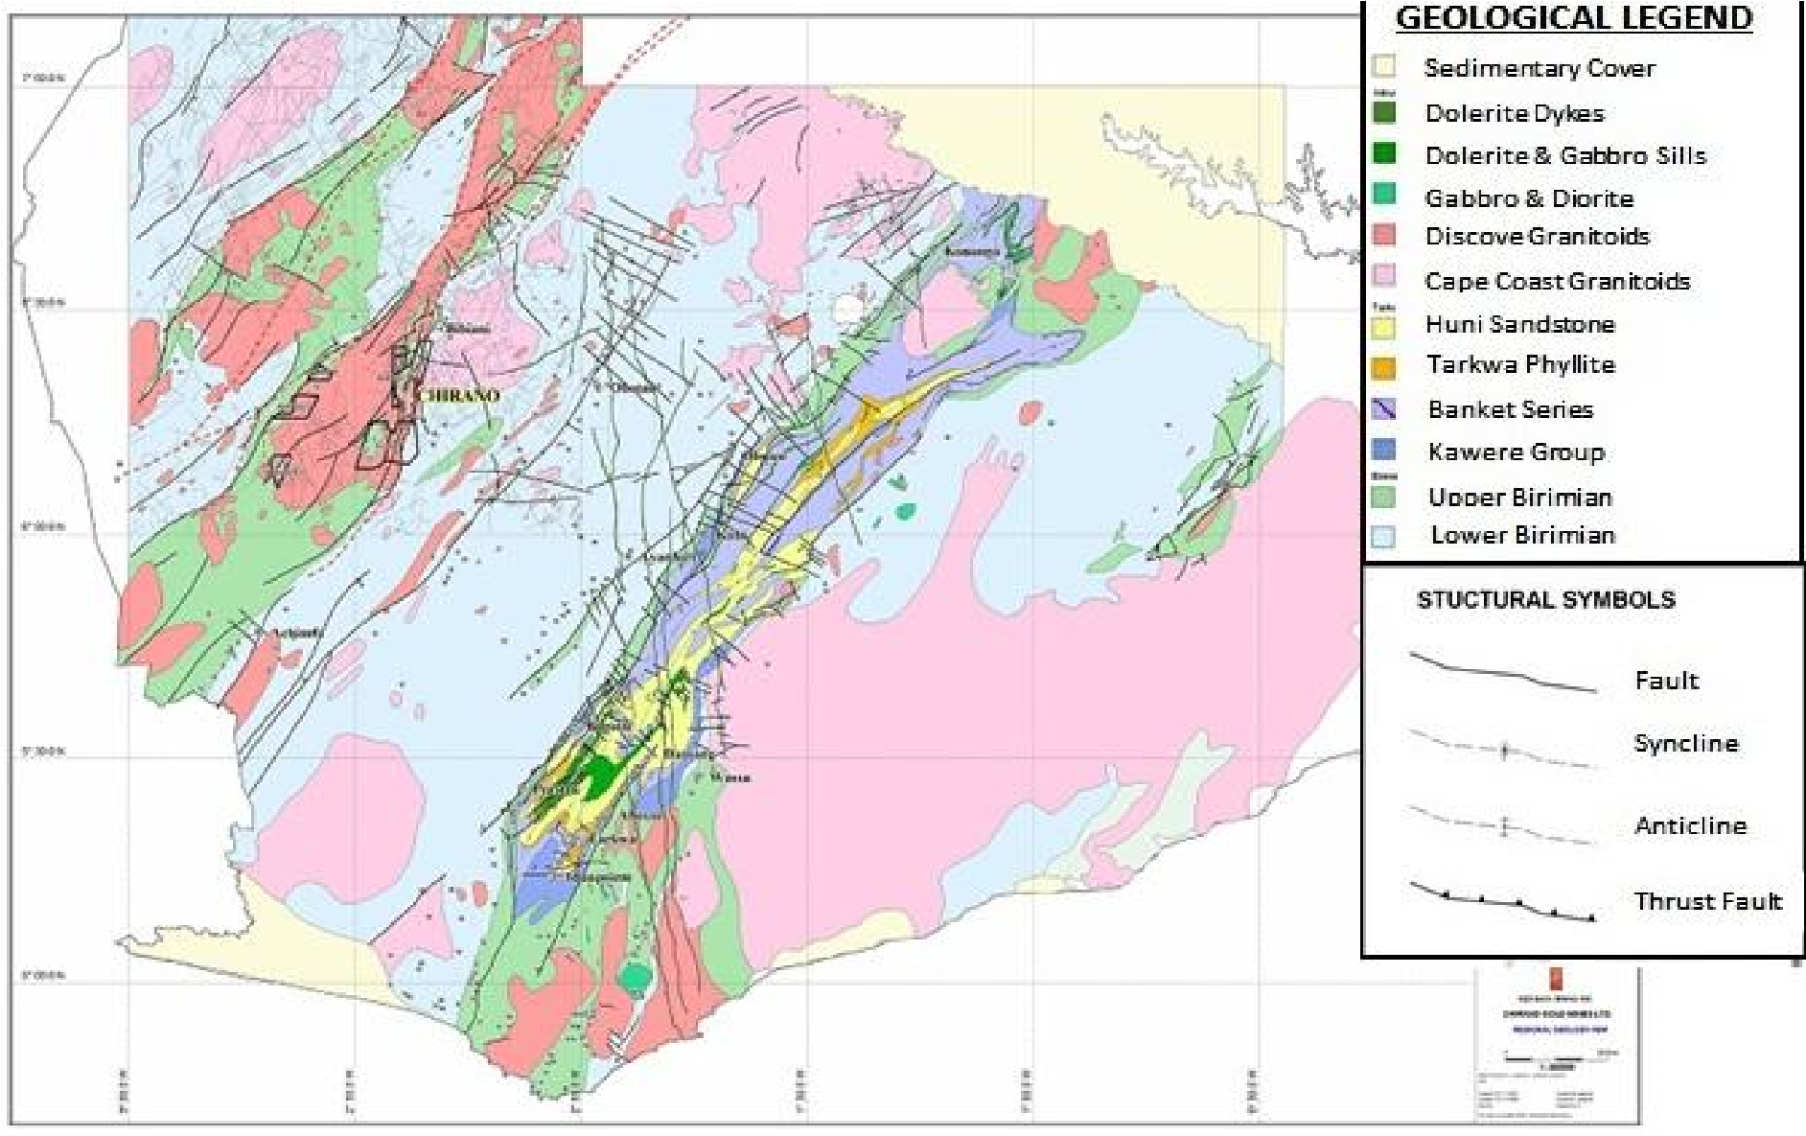

*2.2 Remote Sensing Data and Software*

In this study, a remotely sensed multispectral dataset comprising Advanced Spaceborne Thermal Emission and Reflection Radiometer (ASTER) level 1 T images were processed. One scene of ASTER data could not capture the entire study area so there was the need to acquire two scenes that could be mosaicked to give the needed area of interest. Scene 1 has a path and row of WRS 195 and WRS 55 respectively. and scene 2 has a path and row of WRS 195 and 56 respectively. The capture dates are very important considering vegetation and cloud cover when working in places with a greater presence of vegetation such as the study area (Western Region, Ghana). The images used were captured on January 13, 2007, and were obtained from USGS. Other datasets include a fracture map, geochemical data, lithological map, and known gold occurrence areas. ASTER image is a multispectral imaging radiometer that covers VNIR, SWIR, and TIR wavelengths with 14 bands. it has 3 bands in the visible/Near-Infrared bands (VNIR), 6 bands in the Short-Wave Infrared (SWIR), and 5 bands in the Thermal Infrared (TIR), with a spatial resolution of 15 m for VNIR, 30 m for the SWIR; and 90 m for TIR bands. Table 3.1 shows the different characteristics of the 3 ASTER sensor systems. However, the TIR bands were not used in this work since for mineral exploration mapping, the most appropriate bands are located in the VNIR and SWIR as most of the ‘clay minerals’ associated with gold deposits have their diagnostic spectral signatures mostly in the shortwave infrared portion of the electromagnetic spectrum. Digital processing of these multispectral images has been achieved by the use of Erdas Imagine software and GIS (ArcMap 10.5) which are complete digital processing programs capable of carrying out preprocessing, enhancement, transformation, and classification of remote sensing images in order to extract spatial and spectral information that is related to geology, such as lithology, hydrothermal alteration, and structure.

A Geographic Information System (GIS) is an effective tool for generating favorability maps (FM) for mineral exploration by integrating, analyzing, and weighing several exploration datasets. Generation of FM requires (1) geo datasets divided into subclasses affecting mineralization, (2) weighting values representing the relative importance of subclasses of each layer, and (3) scores for each layer based on their importance to mineralization (Ahmed, 2011). The knowledge-driven technique was used to weight the layers in this study.

**Table 1.** Characteristics of the 3 ASTER Sensor Systems

|  |  |  |  |  |
| --- | --- | --- | --- | --- |
| Subsystem | Band No. | Spectral Range (µm) | Spatial Resolution, m | Quantization Levels |
| VNIR | 1 | 0.52-0.60 | 15 | 8 bits |
| 2 | 0.63-0.69 |
| 3N | 0.78-0.86 |
| 3B | 0.78-0.86 |
| SWIR | 4 | 1.60-1.70 | 30 | 8 bits |
| 5 | 2.145-2.185 |
| 6 | 2.185-2.225 |
| 7 | 2.235-2.285 |
| 8 | 2.295-2.365 |
| 9 | 2.360-2.430 |
| TIR | 10 | 8.125-8.475 | 90 | 12 bits |
| 11 | 8.475-8.825 |
| 12 | 8.925-9.275 |
| 13 | 10.25-10.95 |
| 14 | 10.95-11.65 |

(Source: Abrams and Hook, 1998).

GIS is a powerful tool that allows for the integration of disparate digital datasets into a single, unified database. The recommended approach is to compile all of the available geoscientific data within the GIS in the context of an exploration model in order to produce a mineral potential map. Careful consideration must be given in developing the model so that all of the relevant, important aspects of the deposit being sought are represented (Torres, 2007).

*2.3 Flowchart of the Study*

The methodological steps employed in the current study are shown in the methodology Flowchart Figure 3.3.



**Figure 2.** Flowchart of the methodology used in this study.

*2.3.1 Preprocessing Technique.*

A 3 by 3 low pass kennel filter was applied to provide edge enhancement for a better interpretation of the study area, remove image blur, isolate lineaments and directional trends, and improve visual capabilities. The image was already in zone 30N of the Universal Transverse Mercator (UTM) coordinate System, and based on WGS 84 datum. Since it was proposed to work in this coordinate system, there was no need for geometric correction on the image. No radiometric correction was also performed on the image because it has no cloud cover. The image comes with applied geometric coefficients (as shown by its metadata) and was found to be radiometrically balanced. Two scenes of images were mosaicked together to obtain a single image that covers the entire study area without smoothening and feathering. In order not to modify the existing DN values, the nearest neighbor resampling algorithm is made use of. This was followed by subseting to obtain the study area from the entire image downloaded. Remote sensing data comes in DN values which have no unit and physical connotation, so to be able to draw quantitative analysis from such data requires conversion of the DN values to radiance, then to spectral reflectance (TOA) or surface reflectance. This was carried out in the steps below.

**Step 1: DN values to spectral radiance:** This conversion uses the formula Lx = (DN–1) x Unit conversion coefficient (Abrams, 1999). Where, Lx=ASTER spectral radiance at-sensors aperture, DN = unitless DN values for the individual bands. The unit of the radiance takes the unit of the unit conversion coefficient which is (Wm-2Sr-1µm-1). The information in the product metadata on which bands should be for radiance conversion. Table 3.2 shows the various ASTER bands and their corresponding unit conversion coefficients.

**Table 2.** Calculated Unit Conversion Coefficients.

|  |  |  |  |  |
| --- | --- | --- | --- | --- |
| Band No. | Coefficient (Wm-2 Sr-1µm 1)/DN) | | | |
| High gain | Normal Gain | Low Gain 1 | Low gain 2 |
| 1  2  3N  3B | 0.676  0.708  0.423  0.423 | 1.688  1.415  0.862  0.862 | 2.25  1.89  1.15  1.15 | N/A |
| 4  5  6  7  8  9 | 0.1087  0.0348  0.0313  0.0299  0.0209  0.0159 | 0.2174  0.0696  0.0625  0.0597  0.0417  0.0318 | 0.290  0.0925  0.0830  0.0795  0.0556  0.0424 | 0.290  0.409  0.390  0.332  0.245  0.265 |
| 10  11  12  13  14 | N/A | 6.822 x 10-3  6.780 x 10-3  6.590 x 10-3  5.693 x 10-3  5.225 x 10-3 | N/A | N/A |

(Source: Abrams, 1999).

The results of the computation in Step 1 above should fall within the acceptable limit of radiance values for ASTER bands and gains (Table 3.3).

**Step 2: Spectral radiance to TOA reflectance.** Top of Atmosphere (TOA) reflectance for a specific band is calculated using the standard Landsat formula:

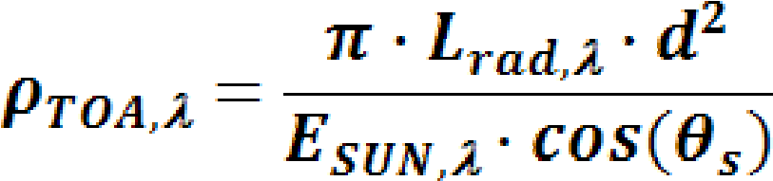

Where,

= Unitless planetary reflectance

= Wavelength, corresponding to a specific band number

= Mean solar exoatmospheric irradiances, illustrated in Table 3.4. Thome et al., 2001 (A) values were used.

L*rad =* spectral radiance at the sensor’s aperture.

d = Earth-Sun distance in astronomical units interpolated from values listed in Table 5

 = Solar zenith angle in degrees (zenith angle = 90– solar elevation angle), which is found in the ASTER header file

**Table 3.** Maximum Radiance Values for ASTER Bands and Gains

|  |  |  |  |  |
| --- | --- | --- | --- | --- |
| Band # | Maximum Radiance (W m-2 sr-1 µm-1) | | | |
| High gain | Normal Gain | Low Gain 1 | Low gain 2 |
| 1  2  3N  3B | 170.8  179.0  106.8  106.8 | 427  358  218  218 | 569  477  290  290 | N/A |
| 4  5  6  7  8  9 | 27.5  8.8  7.9  7.55  5.27  4.02 | 55.0  17.6  15.8  15.1  10.55  8.04 | 73.3  23.4  21.0  20.1  14.06  10.72 | 73.3  103.5  98.7  83.8  62.0  67.0 |
| 10  11  12  13  14 | N/A | 28.17  27.75  26.97  23.30  21.38 | N/A | N/A |

**Table 4.** ASTER Solar Spectral Irradiances (Wm-2 µm-1)

|  |  |  |  |
| --- | --- | --- | --- |
| Band# | Smith: ESUN | Thome et al., 2001 (A): ESUN | Thome et al., 2001 (B): ESUN |
| 1  2  3N  3B | 1845.99  1555.74  1119.47 | 1847  1553  1118 | 1848  1549  1114 |
| 4  5  6  7  8  9 | 231.25  79.81  74.99  68.66  59.74  56.92 | 232.5  80.32  74.92  69.20  59.82  57.32 | 225.4  86.63  81.85  74.85  66.49  59.85 |
| 10  11  12  13  14 | N/A | N/A | N/A |

(Source: Thome et al., 2001).

*2.3.2 Image Processing*

The processing techniques adopted are meant to transform the ASTER data into an image display that would increase the contrast between interesting targets and the background. Some enhancement techniques such as band composite, band ratio, and Principal Component Analysis (PCA) were applied which allowed the extraction of spatial and spectral information related to lithology, structures, hydrothermal alteration, and others. These techniques allow to creation of a mineral potential map of gold mineralization occurrence and delineate mineral exploration targets for further work.

**Table 5.** Earth-Sun Distance in Astronomical Units

|  |  |  |  |
| --- | --- | --- | --- |
| Band# | Smith: ESUN | Thome et al., 2001 (A): ESUN | Thome et al., 2001 (B): ESUN |
| 1  2  3N  3B | 1845.99  1555.74  1119.47 | 1847  1553  1118 | 1848  1549  1114 |
| 4  5  6  7  8  9 | 231.25  79.81  74.99  68.66  59.74  56.92 | 232.5  80.32  74.92  69.20  59.82  57.32 | 225.4  86.63  81.85  74.85  66.49  59.85 |
| 10  11  12  13  14 | N/A | N/A | N/A |

(Source: Landsat 7 ETM+ Data User’s Handbook)

Target delineation involves the analysis and integration of various thematic geological data. To achieve the predictive map, data-driven (empirical) and knowledge-driven (conceptual) methods were applied for the conjugation of the different geospatial datasets, where the results were conditioned by structural, lithological, and geochemical controls. (Bonham-Carter, 1994; Moradi et al., 2015), the approach was to utilize known targets in the study area as training sets on the basis of which unknown targets in the study area could be identified.

*2.3.3 Single Band Combination*

When a composite of three ASTER bands (red, green, and blue) is created, a colorful multispectral image will result, which can be true color or false color. There are different band combination possibilities whereby some of them enhance relevant features for mineral exploration. A composite with the visible bands of the spectrum that correspond to red, green, and blue is called a true color composite. When a composite is created with non-visible bands it is called a false-color composite image. In a false color image, the combination of three bands in red, green, and blue will produce an image that enhances some characteristics depending on the selected spectral bands. The bands are assigned based on the spectral properties of the rocks and alteration minerals (Campos, 2013). Some band composites are useful in a first approach for mineral and rock discrimination and interpret possible alterations based on color intensity variations, such as RGB (7, 5, 1) orthe RGB (5,4, 3).

*2.3.4 Band Ratio*

A digital image-processing technique enhances the contrast between features by dividing a measure of reflectance for the pixels in one image band by the measure of reflectance for the pixels in the other image band. Band rationing is a technique used in remote sensing to effectively display spectral variations (Lu et al., 2004). The type of band ratio employed was to discriminate alteration zones and therefore, the choice of bands depends on their spectral reflectance and positions of the absorption bands of the mineral being mapped. The basic idea of the band ratio technique is to emphasize or exaggerate the anomaly of the target objects (San et al., 2004). In the current studies, alunite, kaolinite, chlorite, muscovite, and goethite minerals are the key targets for finding any alteration zones associated with gold. According to the spectral reflectance curves of these minerals (Figure 3.4), these minerals have different spectral patterns and may have high reflectance values in some spectral portions. However, it may absorb in another spectral region, it is based on this information that the bands were selected for this technique.

According to the spectral reflectance curve of alunite (Figure 4(a)), band 4 (SWIR channel 1) and band 5 (SWIR channel 2) of ASTER data have relatively high and low reflectance respectively Then, to emphasize the alunite mineral occurrence, the channel that the alunite has high reflectance is divided into the other channel that of low reflectance. The suitable band ratio for alunite is the ratio of band 4 over band 5. This same approach was used to discriminate and emphasize the other key minerals, high and low reflectance channels are detected as band 7 and band 6 respectively for kaolinite mineral (Figure 4(b)), then the ratio of band 7 over band 6 is the proper band ratio for kaolinite (Rowan, and Mars, 2002). As depicted in Figure 4(c), chlorite shows absorption peaks in bands 7 and 8 and reflection in bands 6 and 9 of ASTER, as a result, (B6+B9) ∕(B7+B8) can detect chlorite minerals. Muscovite can be identified by band ratio (B5+B7) ∕B6 as its spectra have strong absorption in band 6 while having reflection peaks in bands 5 and 7, according to Figure 4 (d). Band 9,4,1 was used for Goethite depending on its curve shown in Figure 4 (e). The combinations above are used to produce black-and-white images showing areas of the target minerals as bright pixels. To help create alternate colorful images showing the same target zones for the key minerals but with suitable visual capabilities, a set of combinations was performed in Red, Green, and Blue (RGB) for each mineral.

ASTER band ratio 7/6, 4/3, 6/3 (in RGB) was used for Alunite, 7/5, 5/1, 6/1 (in RGB) for Kaolinite, 9/4, 7/5, 7/6 (in RGB) for Chlorite, 8/6, 6/4, 6/5 (in RGB) for Muscovite and 9/1, 8/6, 8/5 (in RGB) for Goethite.

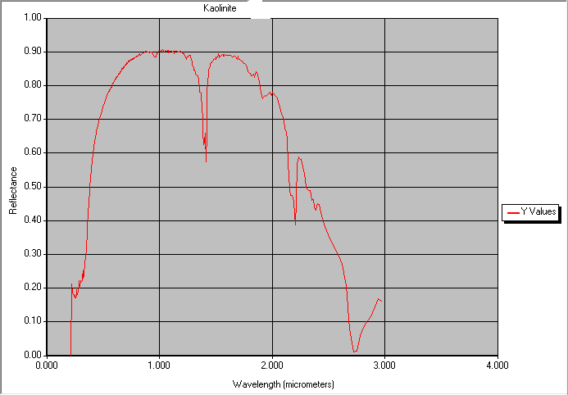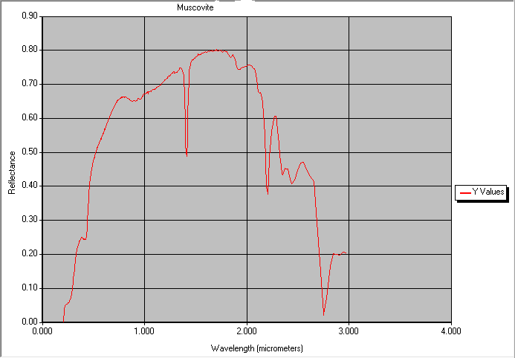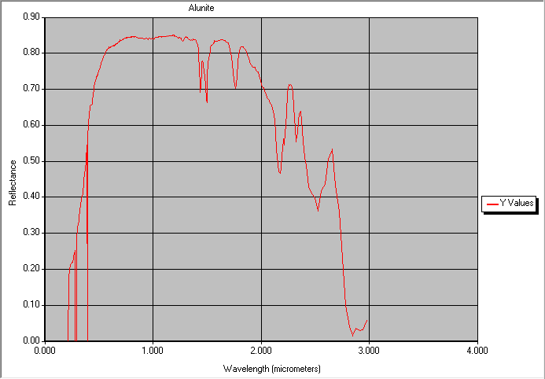.

b

a

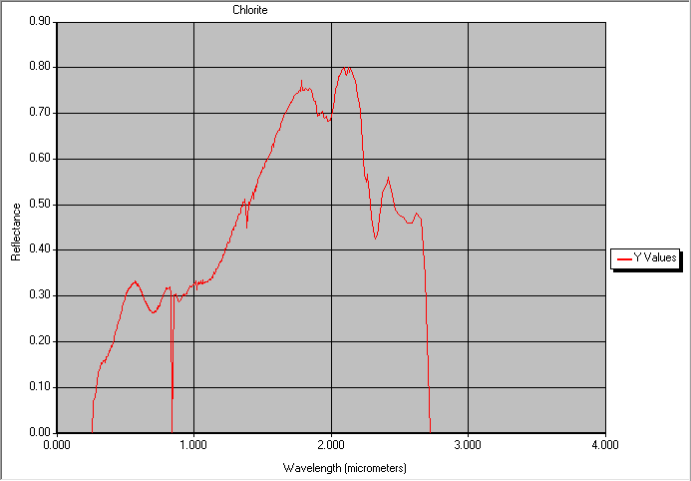

d

c

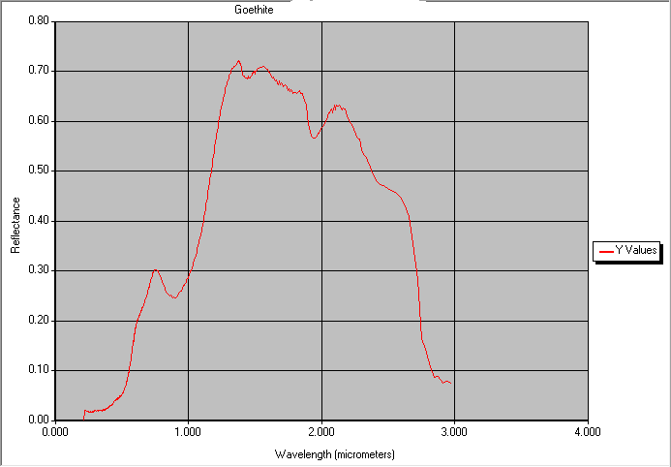

e

Figure 4. The USGS library spectra of the studied minerals. (a) alunite, (b) kaolinite, (c) chlorite, (d) muscovite, (e) goethite.

*2.3.5 Principal Component Analysis (PCA)*

Multispectral images often have similar visual appearance for different bands, thus causing data redundancy (high correlation of spectral bands). PCA is a multivariate statistical technique used to reduce this data redundancy by transforming the original data onto new orthogonal principal component axes producing an uncorrelated image, which has much higher contrast than the original bands (Cosmas, 2010). The Principal Components Analysis (PCA) is a technique used to enhance and separate certain spectral signatures from the background (Gabr et al., 2010; Moradi, 2015). The number of output Principal Components (PCs) is the same as the number of the input spectral bands. The PCs analysis can be used in a standard or selective method (Rajesh, 2004; Van der Meer, 2012). In these studies, the selective analysis method was applied to enhance hydrothermal alteration zones by focusing on the bands with the spectral characteristics of the dominant altered minerals in both VNIR and SWIR.

The first Principal Component, PC1, contains most of the data variability, highlights feature common to all input bands and often displays important structural info. PC1 corresponds to a vector in the direction of the maximum variance of pixels in the scene. The second PC, PC2, contains the second most data variability. It is orthogonal to PC1 in *n* directional space and highlights the spectral differences between visible and infrared spectral bands. The third PC, PC3 includes the third most variability and is orthogonal to the other two PCs. The other PCs have less variability (Gabr et al., 2010; Moradi, 2015). The feature-oriented PCs method (Loughlin, 1991) was used in this study in order to enhance alunite, kaolinite, iron oxide, and hydroxyl-bearing areas. In this selective method, bands with spectral signatures for alunite, kaolinite, iron, and hydroxyl-bearing minerals were only used (Crosta, and Rabelo, 1993; Rajesh, 2004). Iron oxides are a constituent of alteration zones associated with hydrothermal sulfide deposits and can be highlighted by the band 4 / band 2 ratio (Sabins, 1999; Poormirzaee, and Oskouei, 2010; Pour, and Hashim, 2015). Hydroxyl-bearing minerals are the most widespread product of alteration and correspond to a diversity of clays and sheet silicates, which contain Al-OH and Mg- OH-bearing minerals and hydroxides in alteration zones (Poormirzaee, and Oskouei, 2010). The band ratio 6/7 will highlight areas of altered zones comprising dominantly hydroxyl-bearing minerals (Sabins, 1999).

3. Results and Discussion

*3.1.* *Image Analys**is*

*3.1.1. Color Composite Images.*

Single band combinations were performed on ASTER VNIR and SWIR comprising nine bands in an attempt to analyze the study area and visually interpret the multispectral imagery. Different band combinations were created out of the nine bands some of which proved to be useful in enhancing relevant features for mineral exploration. A true color composite image was produced with ASTER bands 4, 3, and 2 (Red, Green, and Blue, respectively) (Figure 4.1). With this band combination, it’s possible to do an exploratory analysis of the area, identifying alteration zones (as hot-pink), vegetated areas (green), rivers (blue), and settlements (pink). A False Colour image was created, using bands 5, 4, and 3 (R, G, B) (Figure 4.2). This band combination allows better differentiation between vegetated areas (blue) and alteration areas (light yellow). The deep yellow colour represents settlement areas. For a preliminary geological study, a contrast-enhanced RGB combination was created. The most contrasting band combination for lithological features that provide more detail without additional enhancement should include one VNIR (1, 2, 3, and 4), and two SWIR (5 to 9) band (USGS, 2015a; USGS, 2015c). Based on this assumption, a composite image using the bands 7, 5, 1 (RGB) was created (Figure 4.3) where it’s possible to identify alteration zones as shades of tan and, vegetation in light blue and water in deep blue.

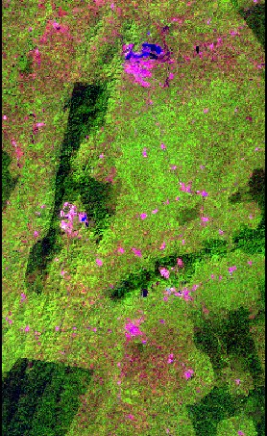

**Figure 5.** True color image, RGB combination of bands 4, 3, 2 blue colors represent water, green represents vegetation, pink represents settlements and hop-pink depicts alteration areas.

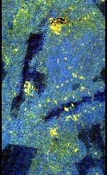

**Figure 6.**  False Colour Composite. RGB combination of bands 5, 4, 3. Light blue represents vegetation, deep yellow shows settlements, and light yellow represents alteration area.

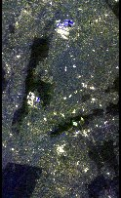

**Figure 7**. RGB combination for bands 7, 5, 1. Enhanced image where alteration areas are represented in shades of tan, Vegetation in light blue, and water in deep blue.

*3.1.2. Results of Band Ratio*

The resulting images from band ratios show an enhanced hydrothermal altered rock with distinctive reflective features. This corresponds directly to minerals associated with this alteration and represents surface expression for auriferous deposits. ASTER band ratio 4/5 was used to highlight areas with abundant iron oxides bearing minerals (i.e. alunite), as brighter pixels (Figure 4.4 (a)), kaolinite (clay mineral), was discriminated with the ratio image of band 7 over band 6, as bright pixels (Figure 4.4 (b)). The ratio image of (B6+B9)/(B7+B8) distinguished altered Chlorite minerals from unaltered rocks altered rocks, where pixels are bright (Figure 4.4 (c)). The ratio of (B5+B7)/B6 highlighted Muscovite as bright pixels (Figure 4.4 (d)). ASTER band ratio 9,4,1 was employed to emphasize Goethite minerals as scarlet-red (Figure 4.4(e)). In order to discriminate altered and unaltered outcrops and highlight areas where the concentration of these minerals occurs, color composite images were created.

Using 7/6, 4/3, and 6/3 as RGB, an image was produced for lithological mapping and hydrothermal alteration zones of alunite (Figure 4.5(a)), in this image, light pink represents alunite alterations, deep red shows forest areas, shallow-red show vegetation and human settlements are shown as white tone.

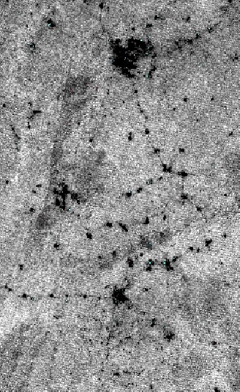

**Figure 8.** (a) ASTER band ratio 4/5 image reveals areas where iron minerals (i.e., alunite) are abundantly shown in bright tones.

An additional RGB composite was created with bands (B4+B7)/B6 and allows the identification of kaolinite (clay mineral) as bright tones (Figure 4.5(b)), Band ratio 9/4, 7/5, 7/6 as RGB was tested for geological purposes, in this image (Figure 4.5(c)) yellow shows settlements, pink shows chlorite minerals, green represent vegetation and light-red represent forest.

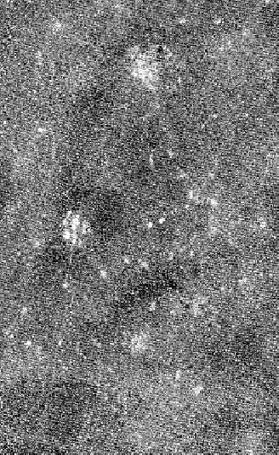

**Figure 8. (b)** ASTER band ratio 7/6 image reveals clay minerals (i.e., kaolinite in bright tones.)

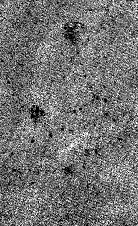

**Figure 4.4 (c)** band ratio (B6+B9)/(B7+B8) image, distinguished altered Chlorite minerals from unaltered rocks altered rocks, where pixels are bright.

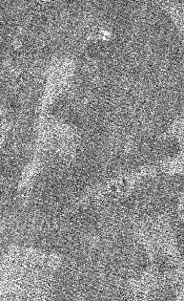

**Figure 4.4 (d**) band ration (B5+B7)/B6 image, highlighted Muscovite pathfinder as bright pixels

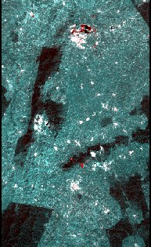

**Figure 4.4 (e)** ASTER band ratio 9,4,4 image shows goethite as scarlet-red, dark shows forest, white represent settlements and ocean-blue represents vegetation.

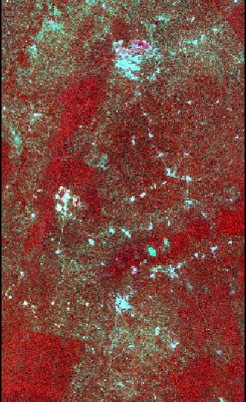

**Figure 4.5 (a)** - ratio 7/6, 4/3, 6/3 as RGB, alunite represented as pink, deep red shows forest, cherry-red shows vegetation and white tone represent human settlement.

Composite image was created for Muscovite with 8/6, 6/4, 6/5 as RGB (Figure 4.5 (d)), and shows Muscovite as yellow, currant-red showing forest, navy-blue represent vegetation and shiny-tone showing settlements. Ratio 9/1, 8/6, 8/5 as RGB was design for Goethite (Figure 4.5 (e)), and depicted Goethite as white-bone, deep green as forest, light-green as vegetation and settlements as white tone.

4.1.3. Result of PCA

Vegetation density is a limitation factor when detecting and mapping hydrothermal altered rocks by band rationing. In order to minimize this limitation a spectral unmixing technique, known as Principal Component Analysis, is applied.

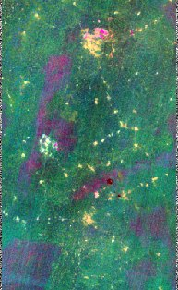

b

c

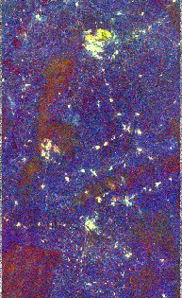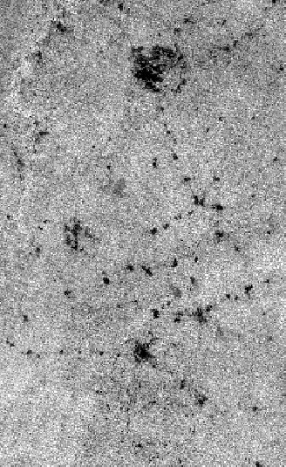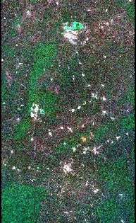

e

c

d

e

d

**Figure 4.5** - (b) bands (B4+B7)/B6 shows kaolinite in bright tones: (c) RGB image with band ratio 9/4, 7/5, 7/6, yellow showing settlements, pink showing chlorite minerals, green represent vegetation and dark-red represent forest: (d) band ratio 8/6, 6/4, 6/5 in RGB image showing muscovite zones as yellow, currant-red showing forest, navy-blue represent vegetation and shining tone showing settlements: (e) band ratio 9/1, 8/6, 8/5 in RGB image showing goethite as white-bone, deep green as forest, light-green as vegetation and settlements as white tone.

In this study, it was carried out through the Crosta technique (Crosta, and Moore, 1987), where the Eigenvector statistics output of PCA was analyzed in way to identify the PC that contains the spectral information of the target minerals. These selected PC images could then show the targeted minerals by highlighting them as bright or dark pixels, according to the magnitude and sign of the Eigenvector Loadings.

For mapping alunite, ASTER bands 1,3,5 and 7 were used. Eigenvectors and eigenvalues loadings for these alunite minerals are shown in Table 4.1. The eigenvector matrix was analyzed allowing for the identification of the Principal Component (PC) that contains spectral information, in comparison with the theoretical signatures (reflection and absorption bands) of alunite, kaolinite, iron oxides, and hydroxyl-bearing minerals (Figure 3.4). Table 4.1 presents the loadings resulting from PCA of ASTER bands 1,3,5 and 7 for alunite minerals enhancement. The PC1 shows the entire eigenvectors loading positive. This corresponds to the albedo image (Figure 4.6(a)) with 58,18% of variance data. PC2 with 40,08% of variance data, and PC3 and PC4 have variance data of 0.92% and 0.81% respectively. PC1 indicates high eigenvector loadings for band 7 and low eigenvector loadings for band 1. These two bands have higher loadings in PC analysis, and the pixels with more abundance of alunite minerals can be identified as bright pixels in the PC1 image (Figure 4.6 (a)). ASTER bands 1,2,3 and 4 were used for mapping iron oxide mineral enhancement. Table 4.2 shows the resulting eigenvectors and eigenvalues. PC1 contains most of the information in that combination i.e., 64.85%, 31.02% of variance data for PC2, PC3 contains 3.79% and forms a RGB image which was useful in discriminating the target mineral (Figure 4.7 (b)). PC4 represents 0.24% of the variance data.

**Table 4.1** Eigenvectors and eigenvalues for Principal Components of ASTER bands 1, 3, 5, and 7 for alunite minerals.

|  |  |  |  |  |
| --- | --- | --- | --- | --- |
|  | PC1 | PC2 | PC3 | PC4 |
| BAND1 | 0.199431656 | -0.090546298 | -0.91089315 | -0.349717103 |
| BAND3 | 0.490085165 | 0.871383501 | 0.013866076 | 0.017749866 |
| BAND5 | 0.599822446 | -0.331271829 | 0.398352705 | -0.609743496 |
| BAND7 | 0.600213778 | -0.350358585 | -0.106754502 | 0.711052571 |
|  |  |  |  |  |
| EIGENVALUES | 0.000687386 | 0.000473588 | 1.09E-05 | 9.60E-06 |
|  |  |  |  |  |
| EIGENVALUES  PERCENTAGE | 58.18233636 | 40.08590323 | 0.918930573 | 0.812829833 |

.

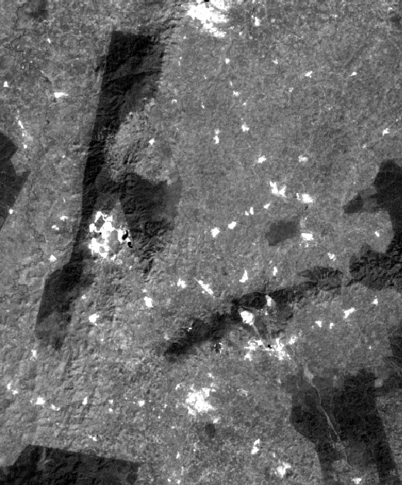 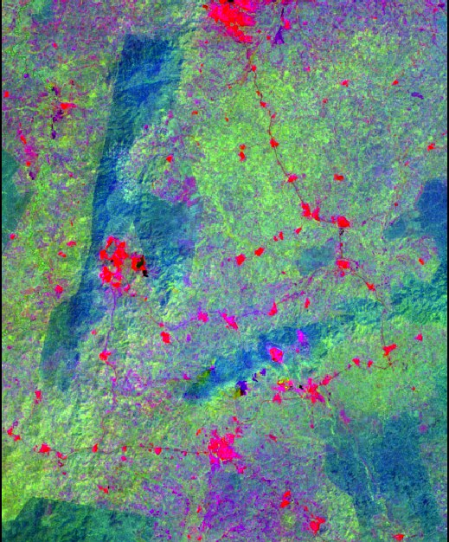

b

a

Figure 4.6 - Principal Component images from ASTER data for alunite minerals (a) PC1 image showing areas of alunite as bright pixels’ dark shows forest, (b)PC3 image where alunite minerals are represented as purple, red represents settlements, lime-green shows vegetation, and navy-blue represent a forest.

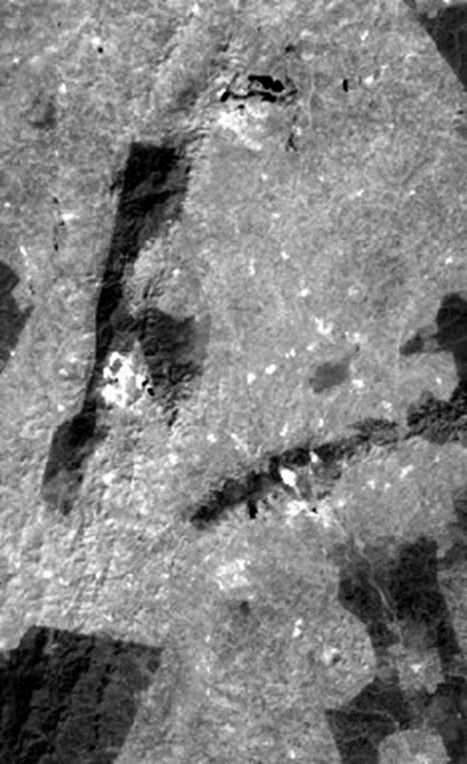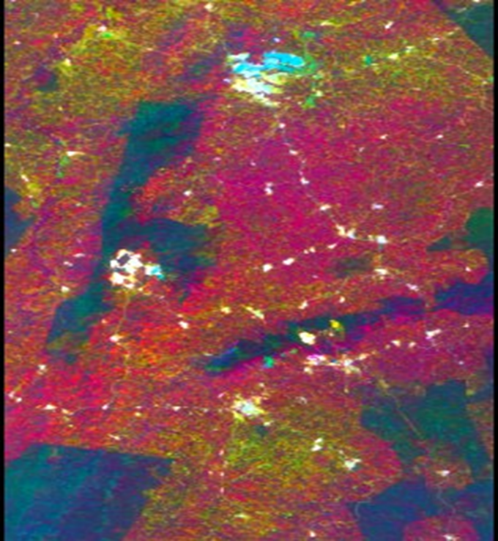

a

b

**Figure 4.7** - Principal Component images from ASTER data for Iron oxide minerals. (a) PC1 image shows areas of iron oxide minerals as bright pixels and black represents forest, (b) PC3 image shows iron oxide minerals as pear-green, hot-pink represents vegetation and pine-green shows forest zones.

PC1 indicates high eigenvector loadings for band 4 and low eigenvector loadings for band 1. Iron oxide minerals have absorption features (low reflectance) in band 1 and reflectance features (low absorption) in band 4. These two bands have higher loadings in PC analysis, and the pixels with more abundance of iron oxides minerals can be identified as bright pixels in PC1 image (Figure 4.7 (a)).

ASTER bands 1,3,4 and 6 were used for mapping hydroxyl-bearing minerals. Hydroxyl-bearing minerals have reflectance features in band and absorption in band 6. Analyzing the resulted Table 4.3, PC1 all the eigenvectors loading positive whereby the albedo image (Figure 4.8(a)) has 67.83% of data variance. PC2 indicates a percentage of 29.99%, PC3 describes the contrast between SWIR bands and VNIR bands with a percentage of 1.47% and the corresponding image shows hydroxyl-bearing minerals as purple (Figure 4.8(b)). PC4 has 0.69% of variance data*.*

**Table 4.2** Eigenvectors and eigenvalues for Principal Components of ASTER bands 1, 2, 3, and 4 for Iron oxide minerals.

|  |  |  |  |  |
| --- | --- | --- | --- | --- |
|  | PC1 | PC2 | PC3 | PC4 |
| BAND1 | 0.156218887 | 0.178498662 | 0.409949115 | -0.88072448 |
| BAND2 | 0.225050934 | 0.410162251 | 0.747777357 | 0.471113605 |
| BAND3 | 0.623857517 | -0.755066891 | 0.195708875 | 0.048721908 |
| BAND4 | 0.731949134 | 0.47935284 | -0.484219768 | 0.001592614 |
|  |  |  |  |  |
| EIGEN VALUES | 0.000790592 | 0.000377665 | 4.61E-05 | 2.98E-06 |
| EIGEN VALUES PERCENTAGE | 64.94565316 | 31.02448817 | 3.785281191 | 0.244577481 |

Bands 1, 4, 6, and 7 were used for mapping kaolinite minerals alteration zones. Kaolinite minerals have a reflection in band 6 and absorption in band 7. From table 4.4, PC1 have all the eigenvectors loading positive whereby the albedo image has 94.35% of data variance, PC2 has 4.03%, PC3 has 0.92% and distinguish kaolinite minerals as purple (Figure 4.9 (b)), PC4 with 0.71% of variance data show negative eigenvector loading for band 6 and positive eigenvector loading for band 7. This means that kaolinite minerals have absorption in band 6 and reflection in band 7. It was expected that these eigenvectors have opposite signs. Using a PC1 image (i.e., PC with much information), kaolinite is mapped as bright pixels (Figure 4.9 (a)).

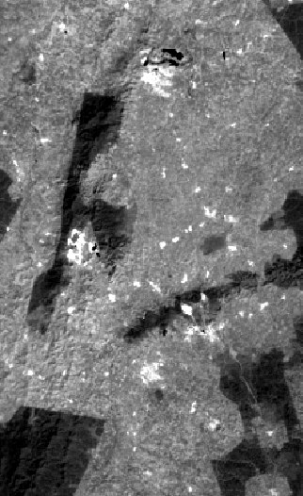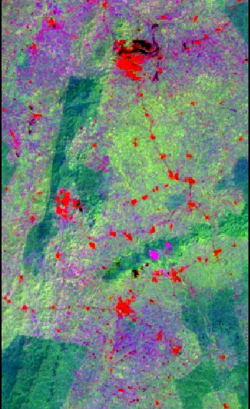

a

b

**Figure 4.8:** Principal Component images from ASTER data for hydroxyl-bearing minerals. (a) PC1 shows hydroxyl minerals as bright pixels and forests as dark. (b) PC3 shows hydroxyl minerals areas as purple, red represents settlements, lime-green shows vegetation, and pine-green represents forest.

**Table 4.3**. Eigenvectors and eigenvalues for Principal Components of ASTER bands 1, 3, 4, and 6 for hydroxyl-bearing minerals.

|  |  |  |  |  |
| --- | --- | --- | --- | --- |
|  | PCA1 | PCA2 | PCA3 | PCA4 |
| BAND1 | 0.157008377 | -0.101663045 | -0.518533168 | -0.834347858 |
| BAND3 | 0.43725728 | 0.880871155 | -0.164156502 | 0.076972216 |
| BAND4 | 0.70812482 | -0.213474419 | 0.631379912 | -0.233125112 |
| BAND6 | 0.531708265 | -0.410072318 | -0.552752569 | 0.49355001 |
|  |  |  |  |  |
| EIGENVALUES | 0.000981245 | 0.000433955 | 2.13E-05 | 1.00E-05 |
| EIGENVALUES  PERCENTAGE | 67.83311458 | 29.9991246 | 1.474764351 | 0.692996474 |
|  |  |  |  |  |

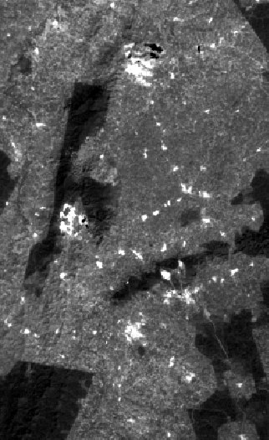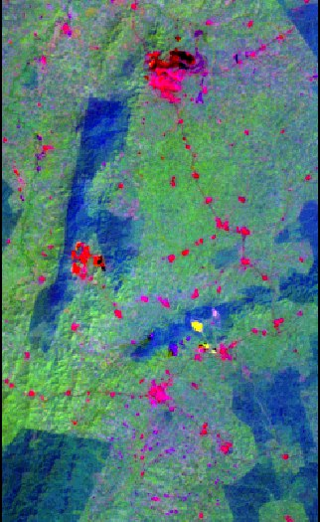

a

b

**Figure 4.9:** Principal Component images from ASTER data for kaolinite minerals. (a) PC1 image depicting kaolinite minerals zones as bright tones, dark as forest. (b) PC3 image showing kaolinite minerals as purple, lime-green as vegetation, red as settlements, and navy blue as forest

**Table 4.4** Eigenvectors and eigenvalues for Principal Components of ASTER bands 1, 4, 6, and 7 for kaolinite minerals.

|  |  |  |  |  |
| --- | --- | --- | --- | --- |
|  | PC1 | PC2 | PC3 | PC4 |
| BAND1 | 0.158594157 | -0.194440039 | -0.926192958 | -0.281438393 |
| BAND4 | 0.651024435 | 0.752099686 | -0.069361311 | 0.075513281 |
| BAND6 | 0.546381193 | -0.373359588 | 0.370064135 | -0.652014375 |
| BAND7 | 0.502476537 | -0.507091462 | -0.020202703 | 0.699976735 |
|  |  |  |  |  |
| EIGENVALUES | 0.001162023 | 4.96E-05 | 1.13E-05 | 8.69E-06 |
| EIGENVALUES  PERCENTAGE | 94.34886108 | 4.030297148 | 0.915427784 | 0.705413984 |

*4.2. Extraction of Features.*

*4.2.1. Structural Mapping*

Geologic and hydrothermal lineaments were extracted based on images from PCA analysis (Figure 4.6b, 4.7b, 4.8b, and 4.9b) which enhanced these patterns. Stretching grey scale and balance will turn more contrasting some structures difficult to identify in raw images. Hillshade processing techniques with the definition of z-factor of 1, azimuth inclination of 315ο, and altitude of 45ο were applied to the DEM data of the study area to extract some useful information and validate others. Delineation of lineaments was done on the resulting image in the PCI Geomatica software environment. The structural information extracted (Figure 4.10) consists of parallel northeast trending faults and horizontal occurring mostly on the rock surfaces. These fracture patterns have an important role as controls on ore deposits acting as conduits of fluids.

*4.3. Target Exploration Map*

A target exploration map that identifies areas where gold mineralization may possibly occur was designed (Figure 4.11). This map was created based on an analysis of the ASTER image of the study area supported by some geological assumptions that: gold mineralization occurs mostly in rocks. The study area is predominantly Birimian and Tarkwaian volcanic-sedimentary rocks. Deposits usually occur associated with geologic structures. The intersection of faults, lineaments, and the dominant rock types is an indication of a possible target area.

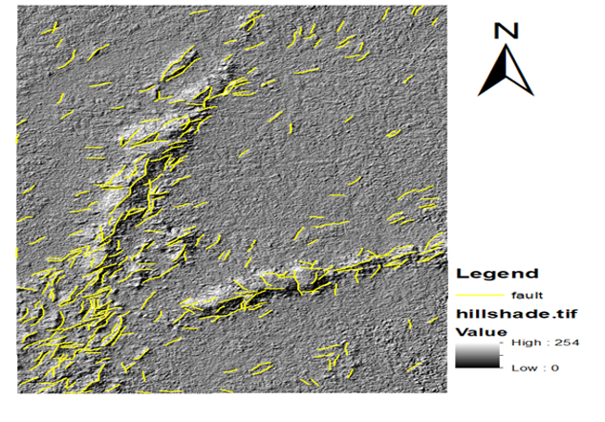

**Figure 4.10:** Structural pattern defined based on ASTER image and terrain analysis

The information extracted from ASTER image analysis made it possible to combine the structural information with the hydrothermal altercation areas. This combination done in the GIS environment defined new exploration target areas, backed by a geological map of the study area and known gold occurrence areas obtained from Chirano Goldmine Limited. It is possible that some known places of mineralization were not identified in this study due to the dense vegetation cover in the study area and ASTER image resolution. However, some areas such as the Chirano and Bibiani deposits which are well-known areas were identified in these studies. In the gold mineral prospectivity map produced (Figure 4.11), black represents faults, yellow represents alteration areas delineated from ASTER image analysis, and all other colors represent rock types of the study area as defined in the legend and was useful in the predictions made here.

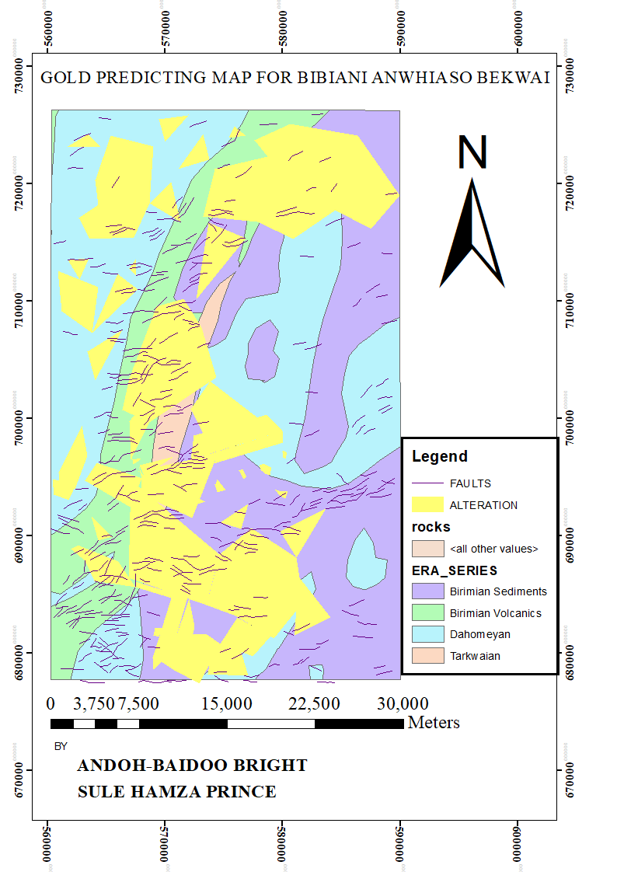

**Figure 4.11**: Target exploration map

Based on assumption 4 above, the new areas found from the processing of the ASTER data as being the intersections between the faults, alteration zones, and the dominant rock type in the location is represented as a map in Figure 4.12.

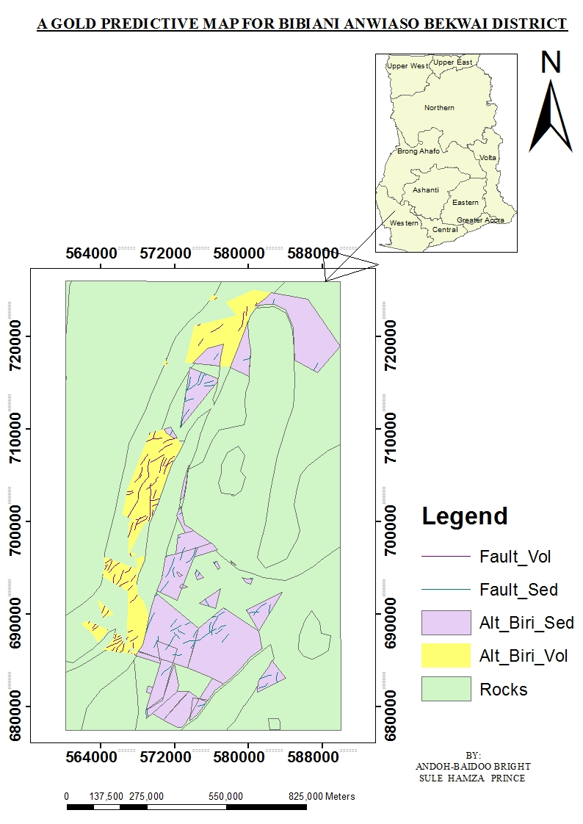

**Figure 4.12.** Mineral prediction map.

5. Conclusions

In mineral exploration projects, remote sensing can be a useful technique to apply in order to define initial exploration targets. In vegetated areas such as the study area, a remote sensing technique is an essential tool to identify fracture patterns that could be used for Au-bearing fluids and highlight hydrothermally altered rocks that are associated with gold deposits. ASTER image enhancement and interpretation proved to be useful in establishing a relationship between the known deposits in the Bibiani and Chirano reserves and similar occurrences in the district and helped in the identification, detection, and delineation of lithological rock units, hydrothermal alterations, and geologic structures associated with gold pathfinders (alunite, kaolinite, chlorite, muscovite and goethite), iron oxide and hydroxide-bearing mineral deposits in the research area. Some single band combinations demonstrated usefulness in alteration delineation. The true color composite image (Figures 4.1 4.2 and 4.3) simulates a photograph where the colors are similar to those visualized by the human eye, and allow the identification of important and visible surface features. The use of ASTER bands 5, 4, and 3 (in R, G, B), enabled vegetated areas to be separated from alteration areas. The use of ratio code techniques enabled lithological and hydrothermal alteration mapping based on diagnostic spectral signatures of the pathfinders associated with gold tackled in this study.

Generally, the band ratios 4/5, 7/6, (B6+B9) ∕(B7+B8)), (B5+B7) ∕B6, and 9,4,1 were utilized for mapping alunite, kaolinite, chlorite, muscovite, and goethite respectively. This processing technique was useful in identifying and delineating areas of gold deposits from other areas. The application of Eigenvector statistics which is based on the Crosta technique of Principal Component Analysis was effective in reducing vegetation density and identifying hydrothermal alteration zones in the area. Together with the band ratio images, the PCA was useful for lineament extraction in the study area. The resulting images from PCA and band rationing were useful in lithological and structural mapping by enhancing the alteration areas. The hill shade processing technique applied to the DEM data enabled the altered and unaltered rocks and their faults to be visible and this analysis helped in delineating the lineaments. This was achieved with the PC Geomatica software. The lithological and structural information extracted from the analysis of the ASTER data were combined with the hill shade information in GIS for the production of the target exploration map. This combination done in the GIS environment was capable of defining new exploration target areas, backed by a geological map of the study area and known gold occurrence areas obtained from Chirano Goldmine Limited. Based on extracted information, a suitable mineral prediction map of the area was design and findings were compared with known data and the results proved remote sensing to be an essential tool in mineral exploration. Geologic mapping is important in evaluating the mineral resources of a location like the study area, in which exploration of its prospecting is likely to be a challenge due to the high density of vegetation cover. To facilitate and reduce exploration expenses, it is best to utilize remote sensing capabilities for such tasks in order to obtain better coverage and accuracy with significantly reduced time and cost. The analysis of ASTER imagery in this study showed that it is effective in data extraction for lithologic information, structural patterns, and highlighting hydrothermal alteration. The target exploration map is obtained by the combination of remote sensing information and other geological data and shows the areas with potential for gold deposits and can be used in further exploration works through the region to discover new alteration zones.

**Supplementary Materials:** The following supporting information can be downloaded at: www.mdpi.com/xxx/s1, Figure S1: title; Table S1: title; Video S1: title.

**Author Contributions:** S.C. conceptualization, formal analysis, writing—original draft, writing—review, and editing. T.B. conceptualization, writing—review, and editing, supervision. A.E. conceptualization, writing—review and editing, co-supervision. S.R. writing—review and editing. E.Z. writing—review and editing. O.I. writing—review and editing. M.B. conceptualization, writing—review and editing, supervision. All authors have read and agreed to the published version of the manuscript.

**Funding:** This research received no external funding

**Data Availability Statement:** Data is available upon request from the authors.

**Acknowledgments:** The experiences and the challenges we went through in the course of pursuing BSc Geomatic Engineering, and subsequently arriving at this level have taught us that, once you set your mind on something, with “GOD” on your side, it is possible. It has not been easy, but we can confidently say that it has been God since day one. All gratitude, appreciation, glory, and honor go to almighty Allah for his strength, guidance, love, mercies, and help, and perfected his strength in our weakness.

Our warmest appreciation goes to Rev. Dr. John Ayer and Dr. E. M. Osei Jnr, our noble supervisors, who took time off their busy schedules to guide, advise, read through, and help us to correct the whole work. We say, your comments were critical and detailed. We thank Prof. A.A Duker, our remote sensing lecturer for the impacted knowledge, on which this work is based. Thanks to the general staff of the Geomatic Engineering Department, we remain grateful**.** Many thanks to Mr. Linus Abisi Ackaah for the role he played in ensuring that the data needed for these studies is secured and to our families for their support in numerous ways in helping make this work a success, especially Mr. Bashiru Sulley Collins.The following friends and loved ones have also been very instrumental in writing this report: Miss Takyiwaa Ophelia (Culture and Tourism Department), Miss Sharifatu Musah (Mathematics Department), Mr. Samuel Dadson, Mr. Osei Jeff Dacosta, and Mr. Yeboah Nicholas, all of Geomatic Engineering Department. You are appreciated.

**Conflicts of Interest:** The authors declare no conflict of interest

References

References must be numbered in order of appearance in the text (including citations in tables and legends) and listed individually at the end of the manuscript. We recommend preparing the references with a bibliography software package, such as EndNote, ReferenceManager, or Zotero to avoid typing mistakes and duplicated references. Include the digital object identifier (DOI) for all references where available.

Citations and references in the Supplementary Materials are permitted provided that they also appear in the reference list here.

In the text, reference numbers should be placed in square brackets [ ] and placed before the punctuation; for example [1], [1–3] or [1,3]. For embedded citations in the text with pagination, use both parentheses and brackets to indicate the reference number and page numbers; for example [5] (p. 10), or [6] (pp. 101–105).

1. Abedi, M., Norouzi, G.-H., and Fathianpour, N., 2013. Fuzzy outranking approach: a knowledge- driven method for mineral prospectivity mapping. International Journal of Applied Earth Observation and Geoinformation, 21, 556–567. doi: 10.1016/j.jag.2012.07.012.
2. Abrams, M., Hook, S., 1998, Aster User Handbook, Version 1, NASA/Jet Propulsion Laboratory, Pasadena.
3. Abrams, M., Hook, S. And Ramachandran, B., 1999, Aster User Handbook, Version 2, NASA/Jet Propulsion Laboratory, Pasadena.
4. Allibone, A., Teasdale, J., Cameron, G., Etheridge, M., Uttley, P., Soboh, A., Appiah-Kubi, J., Adanu, A., Arthur, R., Mamphey, J. (2002). Timing and structural controls on gold mineralization at the bogoso gold mine, ghana, west africa. Economic Geology, 97(5): pp. 949–969.
5. Boloki, M., & Poormirzaee, R. (2009). Using ASTER Image Processing for Hydrothermal Alteration and Key Alteration Minerals Mapping in, 3(2), 38–43.
6. Bonham-Carter, G.F., 1994. Geographic information systems for geoscientists: modelling with GIS. Tarrytown, NY: Pergamon.
7. Caldas M.M., Goodin D., Sherwood S., Campos Krauer J.M., Wisely S.M. (2013) - Land- cover change in the Paraguayan Chaco: 2000-2011. Journal of Land Use Science. doi: http://dx.doi.org/10.1080/1747423X.2013.807314.
8. Carranza, E.J.M., 2008. Geochemical anomaly and mineral prospectivity mapping in GIS. Amsterdam: Elsevier.
9. Carranza, E.J.M., 2011. Geocomputation of mineral exploration targets. Computers & Geosciences,37 (12), 1907–1916.
10. Carranza, E.J.M. and Hale, M., 2001. Logistic regression for geologically constrained mapping of gold potential, Baguio district, Philippines. Exploration and Mining Geology, 10 (3), 165–175.
11. Carranza, E.J.M., et al., 2008. Knowledge-guided data-driven evidential belief modeling of mineral prospectivity in Cabo de Gata, SE Spain. International Journal of Applied Earth Observation and Geoinformation, 10 (3), 374–387. doi: 10.1016/j.jag.2008.02.008.
12. Chan, J.C.-W. And Paelinckx, D., 2008. Evaluation of random forest and Adaboost tree-based ensemble classification and spectral band selection for ecotope mapping using airborne hyper- spectral imagery. Remote Sensing of Environment, 112 (6.)
13. Chica-Olmo, M., Abarca, F., and Rigol, J.P., 2002. Development of a decision support system based on remote sensing and GIS techniques for gold-rich area identification in SE Spain. International Journal of Remote Sensing, 23 (22), 4801–4814. doi:10.1080/
14. Clark, R.N., Swayze, G.A., Wise, R., Livo, E., Hoefen, T., Kokaly, R. & Sutley, S.J., 2007. USGS digital spectral library splib06a: U.S. Geological Survey, Digital Data Series 231.
15. Crosta, A. P. & Rabelo, A., 1993. Assessing of Landsat TM for hydrothermal alteration mapping in central western Brazil. Proceedings of Ninth Thematic conference geologic remote sensing Pasadinea, p. 1053-61, California, USA.
16. Cuihua, C., 2011. Mineral prospectivity mapping integrating multi-source geology spatial data sets and logistic regression modeling. In: Proceedings of the 2011 IEEE international conference on spatial data mining and geographical knowledge Services (ICSDM 2011), 29 June–1 July, Fuzhou: IEEE, 214–217.
17. Darko E (2012), the existence of the Chirano gold mine limited and its effect on the livelihood of the Chirano concession community.
18. Fallon, M., Porwal, A., and Guj, P., 2010. Prospectivity analysis of thePlutonic Marymia Greenstone Belt, Western Australia. Ore Geology Reviews, 38 (3), 208–218. doi:10.1016/j. oregeorev.2010.03.009.
19. Gabr, S., Ghulam, A., Kusky, T. Detecting areas of high-potential gold mineralization using ASTER data. Ore Geology Reviews 2010; 38(1): 59-69.
20. Ghimire, B., Rogan, J., and Miller, J., 2010. Contextual land-cover classification: incorporating spatial dependence in land-cover classification models using random forests and the Getis statistic. Remote Sensing Letters, 1, 45–54.
21. Han, T. & Nelson, J., 2015. Mapping hydrothermally altered rocks with Landsat 8 imagery: A case study in the KSM and Snow field zones, northwestern British Columbia. In: Geological Fieldwork 2014, British Columbia Ministry of Energy and Mines, British Columbia Geological Survey Paper, 2015-1, pp.103-112.
22. Harris, D., 2003. A comparative analysis of favorability mappings by weights of evidence, probabilistic neural networks, discriminant analysis, and logistic regression. Natural Resources esearch, 12 (4), 241–255.
23. Hastie, T., Tibshirani, R., and Friedman, J., 2009. Linear methods for classification. The Elements of Statistical Learning. New York: Springer, 101–137. doi:10.1007/978-0-387-84858-7_4
24. Huang, Z., 2012. Predictive modelling of seabed sediment parameters using multibeam acoustic data: a case study on the Carnarvon Shelf, Western Australia. International Journal of Geographical Information Science, 26 (2), 283–307.
25. http://babda.gov.gh/about-babda.
26. Hunt, G. R. 1971. Spectral signatures of particulate minerals in the visible and near- infrared, Geophysics, v.4201- 513.
27. Kotsiantis, S. and Pintelas, P., 2004. Combining bagging and boosting. International Journal of Computational Intelligence, 1 (4), 324–333.
28. Loughlin WP, Principal component analysis for alteration mapping, Journal Photogrammetric Engineering and Remote Sensing 57,1991, 1163– 1169.
29. Laborte, A.G., Maunahan, A.A., and Hijmans, R.J., 2012. Opportunities for expanding paddy rice production in Laos: spatial predictive modeling using random forest. Journal of Land Use Science, 7 (1), 21–33. doi:10.1080/1747423X.2010.519788
30. Lawrence, R., Wood, S., and Sheley, R., 2006. Mapping invasive plants using hyperspectral imagery and Breiman Cutler classifications (RandomForest). Remote Sensing of Environment, 100 (3), 356–362. doi: 10.1016/j.rse.2005.10.014.
31. Leube, A., Hirdes, W., Mauer, R., and Kesse, G. (1990). The early proterozoic birimian supergroup of ghana and some aspects of its associated gold mineralization. Precambrian Research, 46: pp.139–165.
32. Lewkowski, C., Porwal, A., and González-Álvarez, I., 2010. Genetic programming applied to base- metal prospectivity mapping in the Aravalli Province, India. In: EGU general assembly 2010. 2–7 May, Vienna: EGU.
33. Lu, D., Mausel, P., Brondizio, E., & Moran, E. (2004). Change detection techniques. *International journal of remote sensing*, *25*(12), 2365-2401.
34. Madani, A. A. (2011). Knowledge-driven GIS modeling technique for gold exploration, Bulghah gold mine area, Saudi Arabia. The Egyptian Journal of Remote Sensing and Space Sciences, 14(2), 91–97. https://doi.org/10.1016/j.ejrs.2011.10.001
35. Kwang C, Osei E. M Jnr, & Duker, A. A (2014). Application of Remote Sensing and Geographic Information Systems for Gold Potential Mapping in Birim North District of ... Application of Remote Sensing and Geographic Information Systems for Gold Potential Mapping in Birim North District of Eastern Region of Ghana, (March). https://doi.org/10.14355/ijrsa.2014.0401.05.
36. Moon, C.J. and Evans, A.M., 2006. Ore, mineral economics and mineral exploration. In: C.J. Moon, M.K.G. Whateley, and A.M. Evans, eds. Introduction to mineral exploration. 2nd ed. Oxford: Blackwell Publishing, 3–18.
37. Moradi, M., Basiri, S., Kananian, A. & Kabiri, K., 2015. Fuzzy logic modeling for hydrothermal gold mineralization mapping using geochemical, geological, ASTER imageries and other geo-data, a case study in Central Alborz, Iran. Earth Sci Inform, 8, pp. 197-205.
38. Oh, H.J. and Lee, S., 2010. Application of artificial neural network for gold-silver deposits potential mapping: a case study of Korea. Natural Resources Research, 19 (2), 103–124. doi:10.1007/s11053-010-9112-2 Pal, M., 2005. Random forest classifier for remote sensing classification. International Journal of Remote Sensing, 26 (1), 217–222. doi:10.1080/01431160412331269698.
39. Pal, M., 2005. Random forest classifier for remote sensing classification. International Journal of Remote Sensing, 26 (1), 217–222. doi:10.1080/01431160412331269698.
40. Pereira Leite, E. and De Souza Filho, C.R., 2009a. Artificial neural networks applied to mineral potential mapping for copper-gold mineralizations in the Carajás Mineral Province, Brazil. Geophysical Prospecting, 57 (6), 1049–1065. doi:10.1111/j.1365-2478.2008. 00779.x
41. Pereira Leite, E. and De Souza Filho, C.R., 2009b. Probabilistic neural networks applied to mineral potential mapping for platinum group elements in the Serra Leste region, Carajás Mineral Province, Brazil. Computers and Geosciences, 35 (3), 675–687.
42. Peters, J., 2011. Synergy of very high resolution optical and radar data for object-based olive grove mapping. International Journal of Geographical Information Science, 25 (6), 971–989.
43. Porwal, A., Carranza, E.J.M., and Hale, M., 2003. Artificial neural networks for mineral-potential mapping: a case study from Aravalli Province, Western India. Natural Resources Research,12 (3), 155–171. doi:10.1023/A:1025171803637.
44. Porwal, A., Carranza, E., Hale, M., 2003. Knowledge-driven and data- driven fuzzy models for predictive mineral potential mapping. Natural Resources Research 12 (1), 1–25.
45. Porwal, A., Yu, L., and Gessner, K., 2010b. SVM-based base-metal prospectivity modeling of the Aravalli Orogen, northwestern India. In: EGU general assembly 2010. 2–7 May, Vienna: EGU. Quinlan, J.R., 1993. C4.5 programs for machine learning. 1st ed. San Mateo, CA: Morgan Kaurmann.
46. Pour, A., & Hashim, M., 2015. Hydrothermal alteration mapping from Landsat-8 data, Sar Chesmeh copper mining district, south-eastern Islamic Republic of Iran. Journal of Taibah University for Science, 9, 155-166.
47. Rajesh, H. M. 2004. Application of remote sensing and GIS in mineral resource mapping- An Overview, Journal of mineralogical and Petrological Sciences, v.99, 83-103.
48. Ramadan, T. M., & Fattah, M. F. A. (2011). Characterization of gold mineralization in Garin Hawal area, Kebbi State, NW Nigeria, using remote sensing. The Egyptian Journal of Remote Sensing and Space Sciences, 13(2), 153–163. https://doi.org/10.1016/j.ejrs.2009.08.001
49. Rebeiro Boloki, M., & Poormirzaee, R. (2009). Using ASTER Image Processing for Hydrothermal Alteration and Key Alteration Minerals Mapping in, 3(2), 38–43.
50. Rigol-Sanchez, J.P., Chica-Olmo, M., and Abarca-Hernandez, F., 2003. Artificial neural networks as a tool for mineral potential mapping with GIS. International Journal of Remote Sensing, 24 (5),1151–1156.
51. Rodriguez-Galiano, V. and Chica-Olmo, M., 2012. Land cover change analysis of a Mediterranean area in Spain using different sources of data: multi-seasonal Landsat images, land Surface temperature, digital terrain models and texture. Applied Geography, 35, 208–218. doi: 10.1016/j.apgeog.2012.06.014.
52. Rodriguez-Galiano, V.F., 2012. Incorporating the downscaled Landsat TM thermal band in and-cover classification using random forest. Photogrammetric Engineering and Remote Sensing, 78 (2), 129–137.
53. Sabins, F.F., 1999. Remote sensing for mineral exploration. Ore GeologyReviews 14, 157–183.
54. Segl, K., Guanter, L., Kaufmann, H., Schubert, J., Kaiser, S., Sang, B., Hofer, S., 2010. Simulation of spatial sensor characteristics in the context of the EnMAP hyper- spectral mission. IEEE Transactions on Geoscience and Remote Sensing 48, 3046–3054.
55. Samsudin, A. R. (2016). Integrated Data of Remote Sensing and Geophysical Data for Iron Ore Exploration in the Western Part of Wadi Shatti District, Libya, (March).
56. San, B. T., Sumer, E. O., & Gurcay, B. (2004, July). Comparison of band ratioing and spectral indices methods for detecting alunite and kaolinite minerals using ASTER data in Biga region, Turkey. In *Proceedings ISPRS.*
57. Sesnie, S., 2008. Integrating Landsat TM and SRTM-DEM derived variables with decision trees for habitat classification and change detection in complex neotropical environments. Remote Sensing of Environment, 112 (5), 2145–2159.
58. Stuart, H. (2009). Technical Report On the Chirano Gold Mine, Republic of Ghana for, (May).
59. Tangestani, M.H., Moore, F., 2001. Comparison of three principal component analysis techniques to porphyry copper alteration mapping: a case study, Meiduk area, Kerman, Iran. Canadian Journal of Remote Sensing 27, 176–182
60. Thome, K Biggar S, and Slater P: Effects of assumed solar spectral irradiance on intercomparisons of earth-observing sensors (Proceedings SPIE Vol. 4540, pp 260-269; Sensors, Systems, and Next-Generation Satellites, H. Fujisada, J. Lurie, and K. Weber, Eds., December 2001).
61. Torres, C. A. (2007). Mineral Exploration Using GIS and Processed Aster Images, 6513(Spring).
62. Van der Meer, F. D., Van der Werff, H. M., van Ruitenbeek, F. J., Hecker, C. A., Bakker, W. H., Noomen, M. F., & Woldai, T. Multi-and hyperspectral geologic remote sensing: A review. International Journal of Applied Earth Observation and Geoinformation 2012; 14(1): 112-128.
63. Varet, J., 2012. Mineral resources: An overall assessment. Ressources minérales: Un état des lieux, (381), 29–54.
64. Vincenzi, S., 2011. Application of a random forest algorithm to predict spatial distribution of the potential yield of Ruditapes philippinarum in the Venice lagoon, Italy. Ecological Modelling, 222 (8), 1471–1478. doi: 10.1016/j.ecolmodel.2011.02.007
65. Zuo, R. and Carranza, E.J.M., 2011. Support vector machine: a tool for mapping mineral prospec- tivity. Computers & Geosciences, 37 (12), 1967–1975. doi: 10.1016/j.cageo

**Disclaimer/Publisher’s Note:** The statements, opinions, and data contained in all publications are solely those of the individual author(s) and contributor(s) and not of MDPI and/or the editor(s). MDPI and/or the editor(s) disclaim responsibility for any injury to people or property resulting from any ideas, methods, instructions, or products referred to in the content.